Exercise of the Week
Week Seven: All Four- Alternating Arms Raises

Purpose
1. To strengthen the intrinsic stabilization core muscles
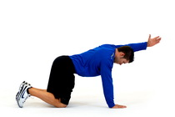
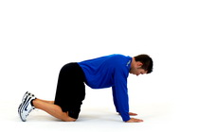
2. To strengthen the rhomboids, middle and lower trapezius and supraspinas muscles.

Prepartation
1. Start on hands and knees with your weight evenly distributed, chin tucked in and neck
parallel to the floor.

Starting position End position
Movement
2. Do the drawing-in maneuver (navel drawn in, and gluteals activate).
3. Slowly stretch one arm out to the front of you being careful not to raise your arm over
head. Hold for 2 seconds.
4. Slowly return to the starting position to a count of 4 seconds.
5. Repeat 5 to 10 times with the same arm.
6. Switch to your other arm and repeat steps 2 to 5.

Key Points
1. Maintain the drawing-in maneuver throughout this exercise. This ensures the intrinsic core
stabilizers are staying activated.
2. Keep your chin tucked in, neck parallel to the floor, and spine straight throughout this
exercise. Do not arched your neck back.

Youtube Instructional Video

Below is an excellent instructional youtube video all how to do the All Four
Extension Core Stabilization exercise. Even though this exercise explains how to do the exercise with your arms and legs, just do only the arm extension.
https://www.youtube.com/watch?v=Vtn2wBvlrwA

