Exercise of the Week
Week Five: The Standing Iliopsoas Stretch

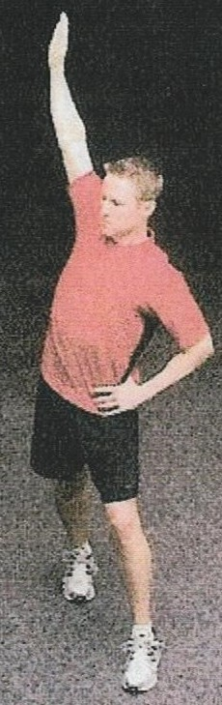
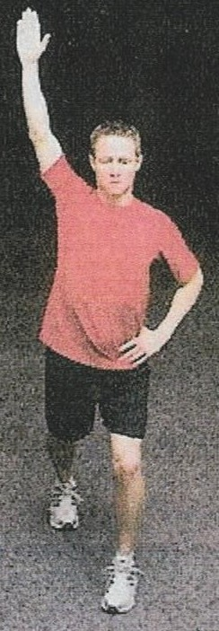
Main objective: To lengthen the Illiopsoas muscle

There instructions on learning the standing Illiopsoas may be difficult to follow so I included the following youtube video that should help you to correctly perform this stretch.

https://www.youtube.com/watch?v=f7LpKdLoF3A

Fig.1 Fig. 2

Preparation:
1. Stand with one leg bent and slightly forward.
2. Internally rotate the back leg.
Movement
1. Gently draw navel inward towards your spine. squeeze your buttocks, and tuck your chin and gently draw neck and head backward. (The draw-in maneuver)

2. While maintaining the draw-in maneuver, slowly move your body forward until you feel a mild tension in the front of the hip being stretched.

3. As a progression, slowly raise your arm (on the same side sane as the back leg) up an over to the opposite side, while maintaining your pelvis position. (fig.1)

4. Hold the side bend position while you slowly rotate posteriorly. (fig.2)

5. Hold for two seconds. Repeat 5 to 10 times.

6. Repeat on the other side.

Make sure that you maintain the draw-maneuver during this stretch. This will reciprocally inhibit the Illiopsoas muscle, allowing for greater lengthening of the Illiopsoas muscle.

