Exercise of the Week
Week Six: Glut Max Activation Exercise

When the Illiopsoas is tight and overactive the opposing muscle (the Gluteus Maximus) is weak and underactive which is one of the major causes of low back and/or hip pain. By doing this week's exercise of the week after stretching your Illiopsoas muscle
(the standing Illiopsoas stretch), you can decrease your chances of experiencing low back and/or hip pain by increasing the muscle balance between you Illiopsoas and Gluteus Maximus muscles.

Starting Position

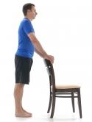
1. Stand holding the back of a chair.

2. Gently pull your navel in and contract the muscles of the buttock
and thigh of the stance leg. Maintain these contractions through
out the movement

Movement

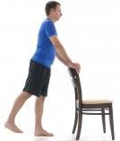
1. While keeping your back straight, extend your leg backward as
far as you comfortably can to a count of one second.

2. Hold for two seconds.

3. Slowly return to the starting position to a count of four seconds.

4. Repetitions: Work up to two seconds of 10 15 repetitions.

Here is a youtube instructional video for the Extending Hip exercise
https://www.youtube.com/watch?v=6PvIZIIg_Ng

